**Basic EC Lab Exam**

|  |  |
| --- | --- |
| **Name:** | Keerti P. Charantimath |
| **Roll Number:** | 19MA20059 |

1. **Problem Statement:**

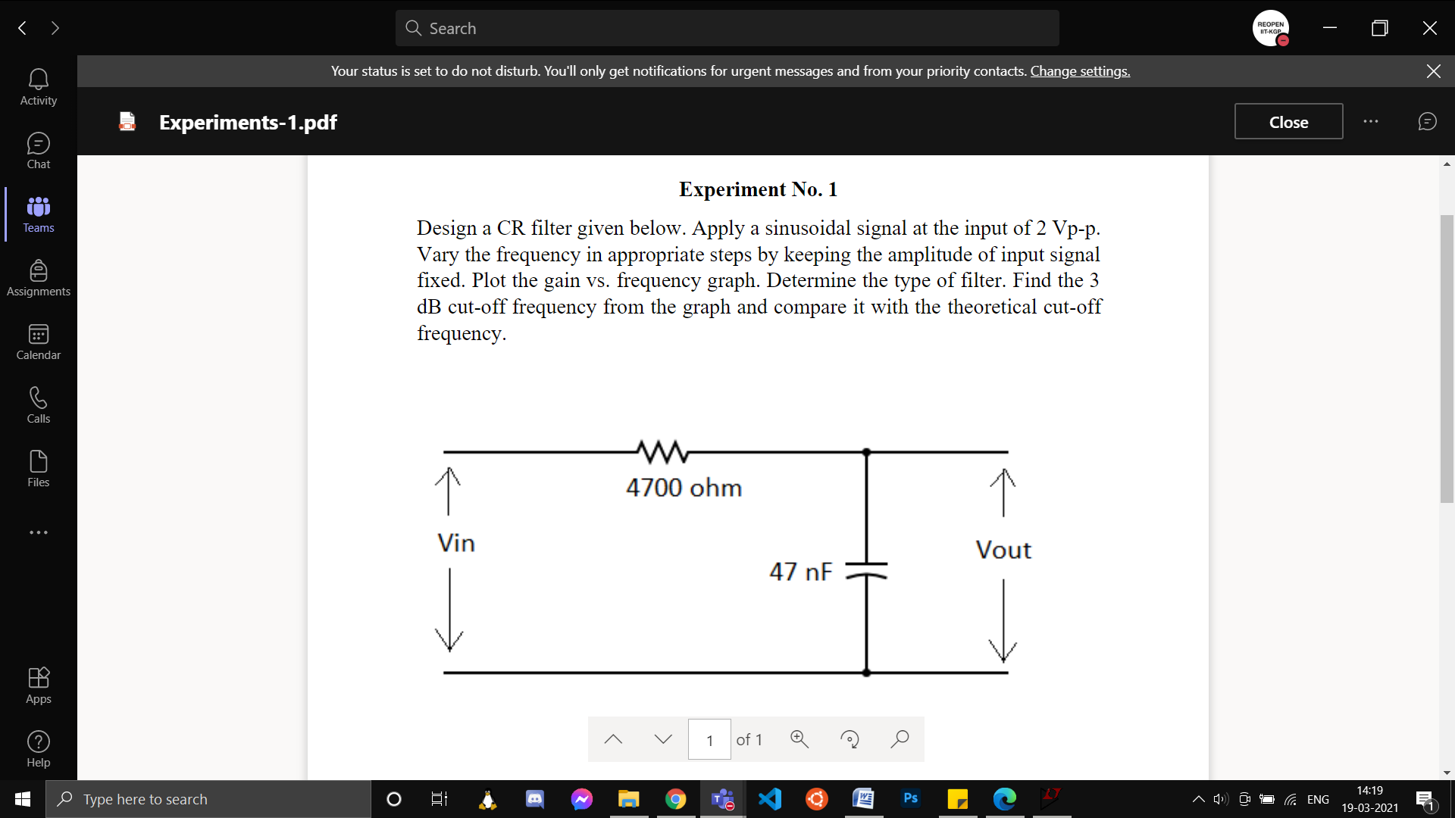

1. **Aim of the experiment:**

* To analyse the frequency response of the given circuit (low pass filters).
* To verify the theoretical and experimental values of 3dB cutoff frequency for the given circuit.

1. **Software Used:** LtSpice
2. **Tools used:**

* 4700 ohm resistor
* 47 nF capacitor
* Wires
* AC voltage source with amplitude 1 V and variable frequency

1. **Circuit :**

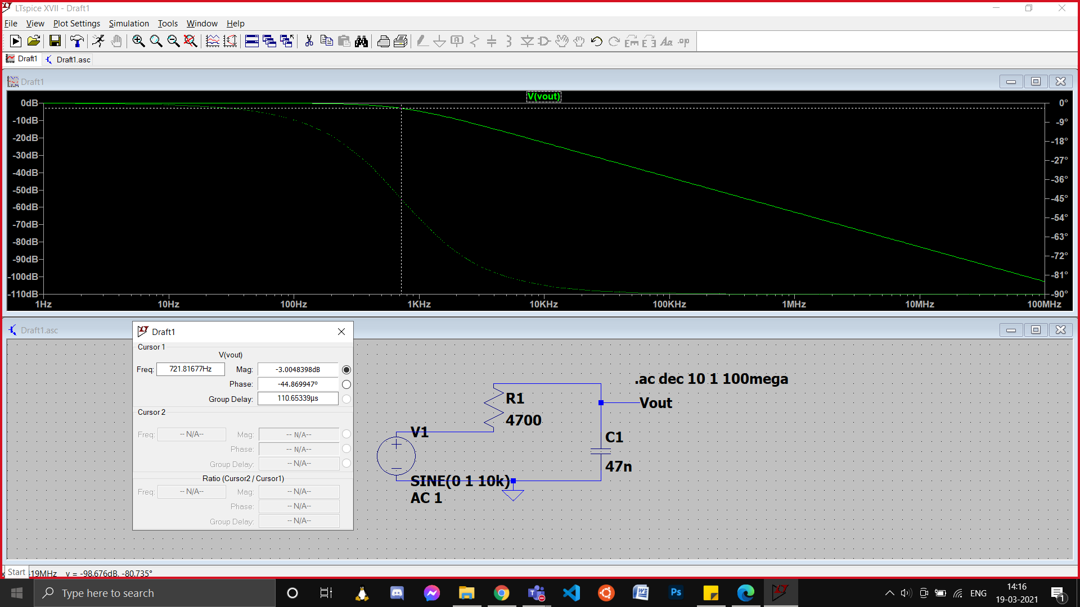

1. **Graph :**





1. **Calculation:**

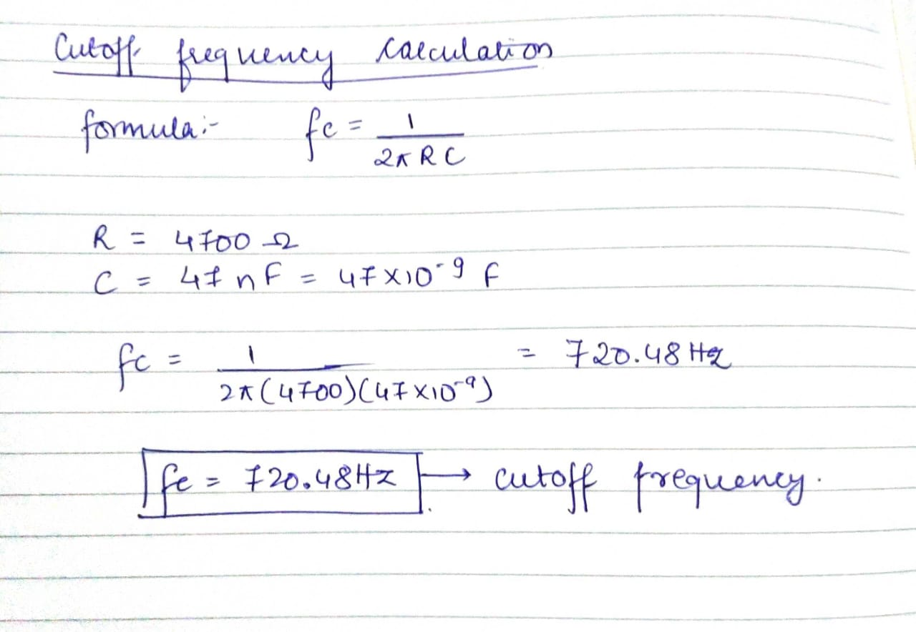

1. **Conclusion:**

* The given RC filter is a **low pass filter.** It filters out high frequency inputs and alloes only low frequency inputs to pass through it.
* The **3 dB cutoff frequency according to the graph** is approximately **721.81 Hz.**
* The **calculated value of 3dB cutoff** **frequency** is **720.48 Hz.**
* Hence, the experimental and the theoretical values of cutoff frequency are are approximately of the   
  same value.

1. **Discussions:**

* While performing the experiment, I observed that there were jumps in the graph initially as the data points I was plotting were far apart from each other. I finally got a smooth frequency response graph   
  as when I increased the number of data points plotted in any frequency interval. In other words I plotted points that were close enough to give a smooth output graph.
* Low pass filters are used as noise filters. Noise has high frequency that is filtered out by low pass filters.
* Ideally we need to observe a phase shift of 900 but we see that this doesn’t happen suddenly. The phase shift happens gradually and finally reaches –900 from 00 at high frequencies.